H&S Autoshot HSS200 Synergic “3-in-1” Welder
200-Amp, Capacity 7/16” (110-240VAC)

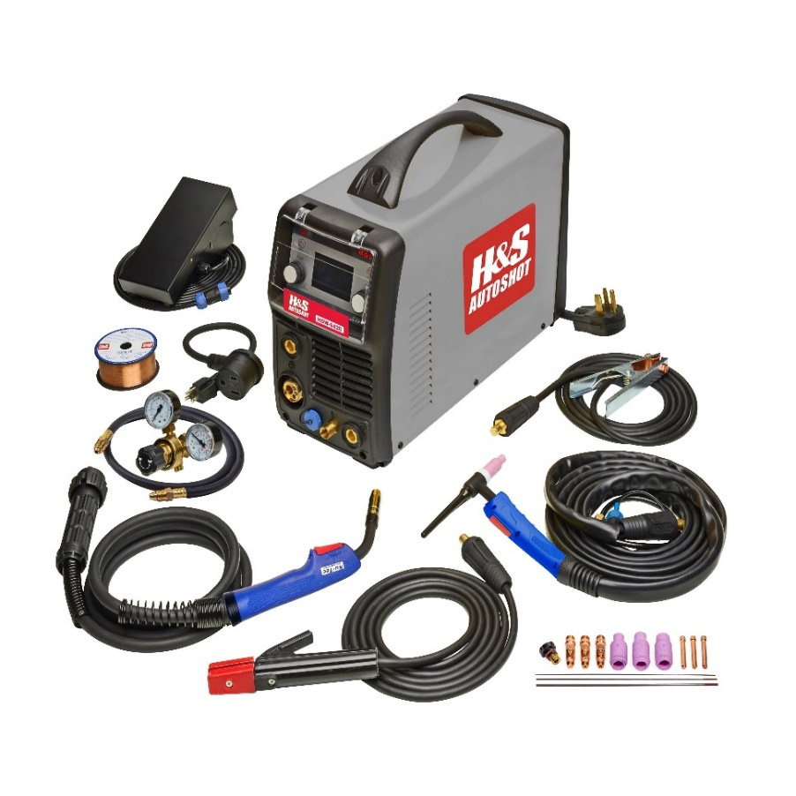

HSS200 – Synergic DC MultiMig

The model HSS200 is the Smart Multi-Mig choice of professionals as the only unit to feature full Synergic welding capability on a DC Multi-Mig welder with operator setting on large LCD display. It’s completely versatile with 110-240 volt input capability, MIG and TIG switch select operation with both torches connected at all times and no requirement to remove MIG wire.

System features IGBT inverter power supply with 0.99 efficiency PFC dual voltage (115 & 230 volt) input with a compact air-cooled cabinet with the highest duty-cycle rating in class. Operating features include LCD control panel, full synergic operation, infinitely variable output power from 30-200 amps, auto over-temp and over-voltage protection. In TIG mode, lift-arc start, ramp/slope, pulse, frequency, pre & post gas select with foot pedal control. Arc electrode operation includes hot start & arc force adjustment. Optional aluminum spool gun is available for plug-&- go operation.

Package includes PFC power supply with LCD Screen, HSL15 MIG gun, HST17 TIG torch with quick-connect welding cable 12.5’, 200A work clamp with quick-connect welding cable 10’, 200-amp electrode holder with quick-connect welding cable 10’, foot pedal control with direct-connect cable, 115-volt jump-power cord, dual-gauge gas regulator, AK-2 torch kit and operator manual.

Input Power: 110-240VAC Single-P 50/60 Hz Output Power: 30-200 Amps (DCV)
Input Current: 35 amps (Max. @ 208VAC) Duty-Cycle: 35% @ 200 Amps
Dimensions: 21.62” x 8.43” x 15.56” (550x214x395) Weight: 31 Lbs. (15 Kg)
Shipping carton: 29.75” x 14.75” X 21.75” Shipping weight: 52 Lbs.
Tungsten electrode: 1/16” (max.) DC Thoriated Stick electrode: 3/16” (max.)
Optional Accessories Include:

HSW-7000: Machine cart, heavy-duty powder-coated steel with 3-shelves and gas cylinder support.
HSW-7009: TIG foot pedal ON/OFF and output power control with direct-connect cable assembly 12.5 ft.
HSW-7016: TIG-17 torch, trigger and thumbwheel power control with direct-connect cable assembly 12.5 ft.
HSW-7017: TIG-17 torch, trigger control with direct-connect cable assembly 12.5 ft.
HSW-7019: Arc electrode holder 200A with direct-connect cable assembly 12.5 ft.
HSW-7020: Spool gun 220A for aluminum, silicone bronze or steel wire with direct-connect cable assembly 20 ft.

