
HSW-6260 250-Amp Mig Welder
With Direct-Connect Spool Gun*

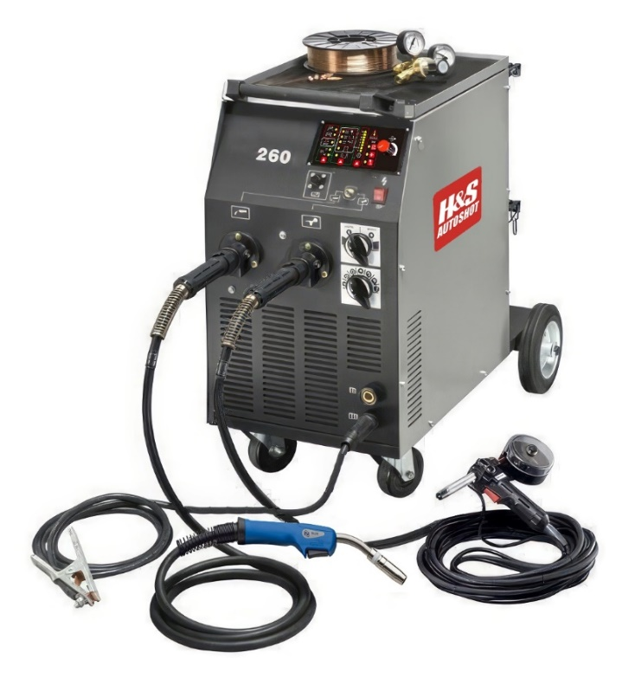
*Shown with optional spool gun

HSW-6260 Description

The H&S Autoshot 260D is the workhorse 250-amp MIG welder for automotive and industrial professionals with unparalleled reliability and performance. This heavy-duty machine offers hand-held torch wire feed steel and/or spool gun drive aluminum welding with wire sizes from .023”-.045”. The unit features “Switch-on-the Fly” toggle control between the steel MIG gun with mixed gas and aluminum MIG spool gun with 100% argon gas due to its’ dual cylinder cart and dual gas valve design. With 250 amps of power, it is capable of welding all steel and aluminum alloys from #20GA to ½” plate.

The system features heavy-duty transformer power supply with epoxy sealed components in a full-size shop cabinet with the highest duty-cycle rating in class. Operating features include digitally controlled infinitely variable wire speed output power from 10-250 amps and operator selectable 2T / 4T trigger, post gas, slow feed, burn back and spot timer.

Package includes 250-amp MIG power supply with SL25 MIG gun with euro-connect welding cable 10-ft, 250A work clamp with quick-connect welding cable 10’, dual gas regulators and hose with 5/8-18 fittings, 8” spool of ER70S6 steel wire .030” diameter and operator manual.

Specifications:

Input Power: 208-240VAC Single-P 50/60 Hz Output Power: 30-250 Amps (DCV)
Input Current: 42 Amps (NEMA 6-50P Cord) Duty-Cycle: 35% @ 250 Amps
Dimensions: 31.5” x 17.5” x 31.0” Weight: 221 Lbs. (100 Kgs.)
Control Panel Functions:

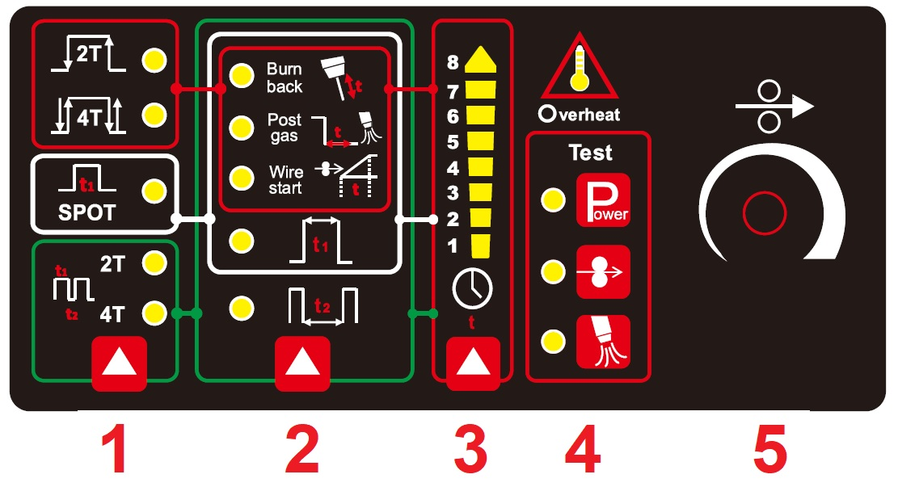

Trigger Circuit: Select 2T (on/off), 4T (latching), Spot (timer) 2T-Pulse or 4T-Pulse.

Parameter Settings: Select and adjust the following parameters:

Burn Back LED: Set burn back time from 1 – 8 using #3 touch pad.

Post Gas LED: Set post gas flow time from 1 – 8 using #3 touch pad.

Wire Start LED: Set slow-start wire feed time from 1 – 8 using #3 touch pad.

Spot Time LED: Set spot weld timer from 1 – 8 using #3 touch pad.
  - Pulse Time LED: Set pulse rate, in 2T or 4T, from 1 – 8 using #3 touch pad.

- Timer Setting: Push to select timer from 1- 8 when parameter LED is illuminated.

- Test / Set-Up: Push to confirm operations or external connections:

  - Power: Press to illuminate green LED confirming LINE power is correct.
  - Wire Feed: Press to manually feed wire through MIG gun on set-up.
  - Shield Gas: Press to confirm and measure gas flow at MIG nozzle.

- Wire Speed: Rotate knob to increase or decrease wire speed.

Optional Accessories:
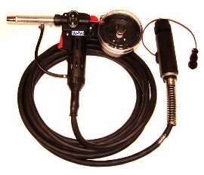
HSW-7022 Spool Gun 185A with 20-foot euro-connect coaxial power cable.
- Supports standard 4-Inch spools steel, aluminum or silicone bronze wire.
- Standard drive rolls for .030” and .035” welding wires included.
- Consumables are interchangeable with Miller Spoolmate style.
- Quick connect euro style power cable and shield gas plug.
- Quick connect 4-pin circular control lead cable plug.

