**H&S Autoshot HSW-6215 Multi-MIG Welder**

**140-Amp Inverter 1/4” (115VAC)**

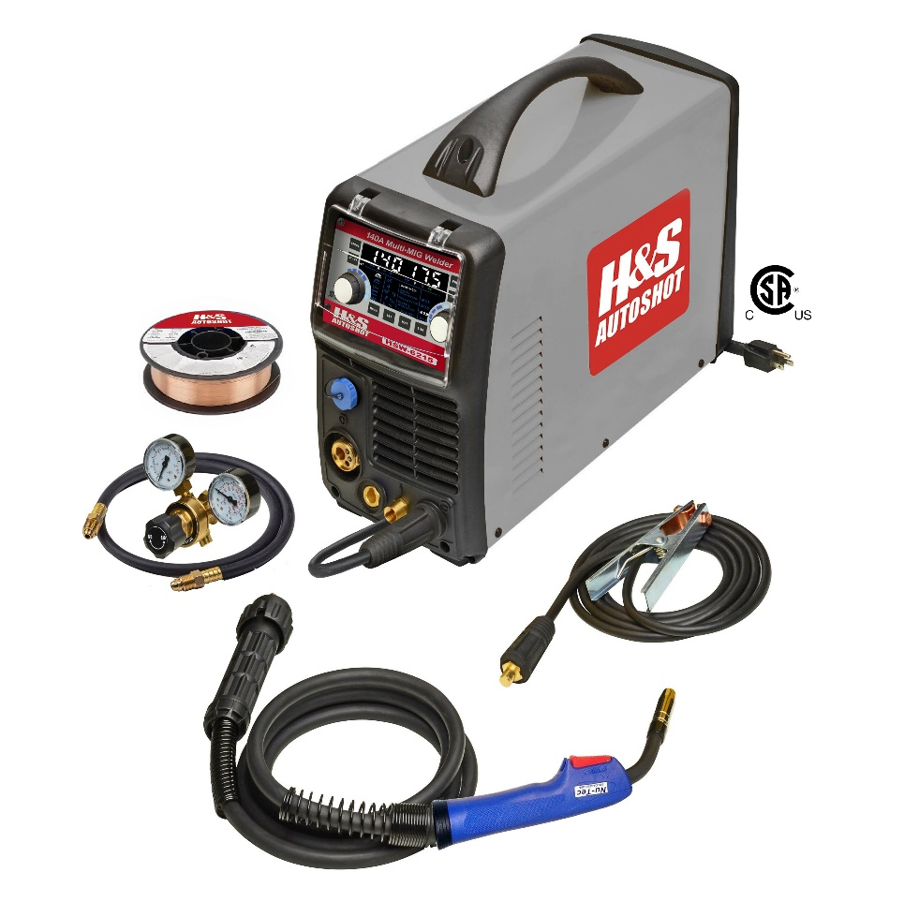

***HSW-6215***

The model H&S Autoshot 6215 is the most powerful 115-volt portable Multi-MIG welder on the market today with 140 Amps of output power @ 35% duty-cycle! It’s completely versatile with manual or ***fully synergic*** MIG for both gas and no-gas (Flux-cored) applications using hand-held torch or optional spool gun. Additionally, it is a Multi-MIG offering optional lift-arc DC TIG and arc electrode stick welding as well as aluminum spool gun capabilities.

The system features CSA/US certified IGBT inverter power supply with epoxy sealed components with the highest duty-cycle rating in class. Operating features include 7” LCD touch pad parameter selection display to select manual MIG, synergic MIG, DC TIG or arc electrode mode. Welding parameter selections include inductance, pre-gas, soft-start, burn-back & post-gas with hot start & arc force when arc electrode welding. Output power range is 35-140 amps @ 115VAC. Wire diameters from .024”/0.6mm to .040”/1.0mm on 4” or 8” spools.

Package includes inverter power supply with 115VAC power cord, SL15 MIG gun & 200A work clamp with UV/IR welding cables, dual-gauge gas regulator with brass hose fittings, mild steel welding wire and operator manual with listing of consumable & maintenance parts.

***Specifications:***

Input Power: 115VAC 50/60 Hz Output Voltage: 14 – 20VDC

Input Current: 20 Amps (min.) Output Current: 35-140 Amps

Wire Sizes: .024”, .030”, .035” on 4” or 8” spool Duty-Cycle: **140 Amps @ 35%**

Dimensions: 18.0” x 9.75” x 16.2” (510*248*410) Weight: 28 Lbs. (12.7 Kg)

Carton Dim.: 26.25” x 15.50” x 22.00” (667 X 394 X 559) Ship Weight: 35 Lbs. (15.8 Kg)

***Electronic Display Functions:***

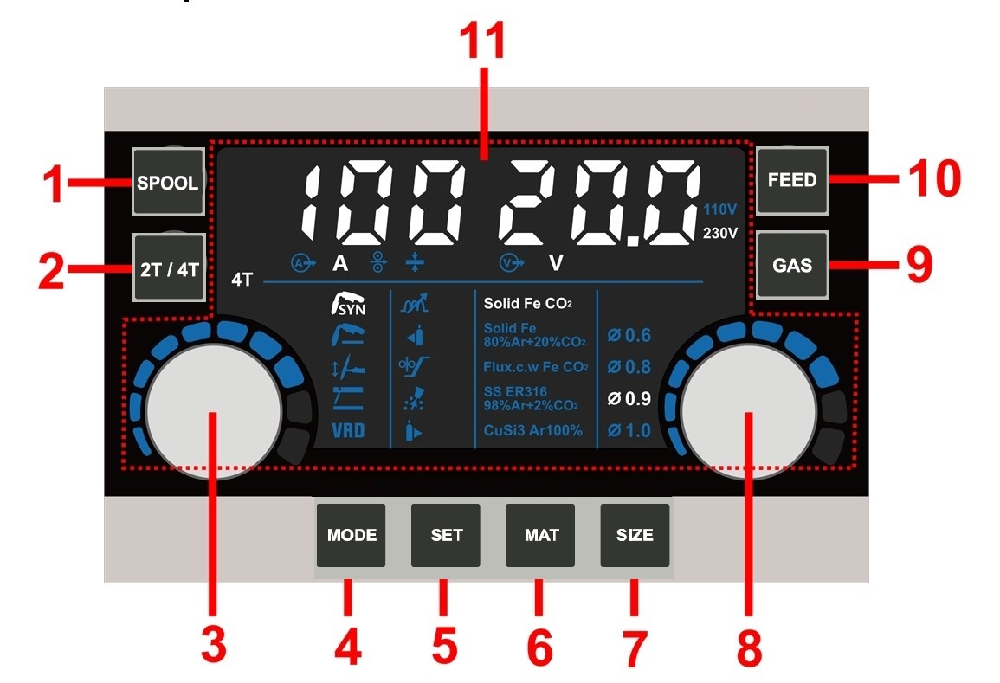

1. Spool gun select touch pad 2. Trigger select touch pad

3. LH parameter setting knob 4. W-mode select touch pad

5. W-parameter select touch pad 6. Wire & gas select touch pad

7. Wire diameter select touch pad 8. RH parameter select knob

9. Gas momentary purge touch pad 10. Wire feed momentary touch pad

11. Displays amperage, wire speed, material thickness & arc voltage settings / Input voltage

***Optional Accessories Include:***

**HSW-7000:** Machine cart, heavy-duty powder-coated steel with 3-shelves and gas cylinder support.

**HSW-7009:** TIG foot pedal ON/OFF and output power control with direct-connect cable assembly 12.5 ft.

**HSW-7016:** TIG-17 torch, trigger and thumbwheel power control with direct-connect cable assembly 12.5 ft.

**HSW-7017:** TIG-17 torch, trigger control with direct-connect cable assembly 12.5 ft.

**HSW-7019:** Arc electrode holder 200A with direct-connect cable assembly 12.5 ft.

**HSW-7020:** Spool gun 220A for aluminum, silicone bronze or steel wire with direct-connect cable assembly 20 ft.

**HSW-7000 HSW-7009 HSW-7016 HSW-7017 HSW-7019 HSW-7020**